

Parent and Young Person Assessment Profile for Education, Health and Care needs assessment

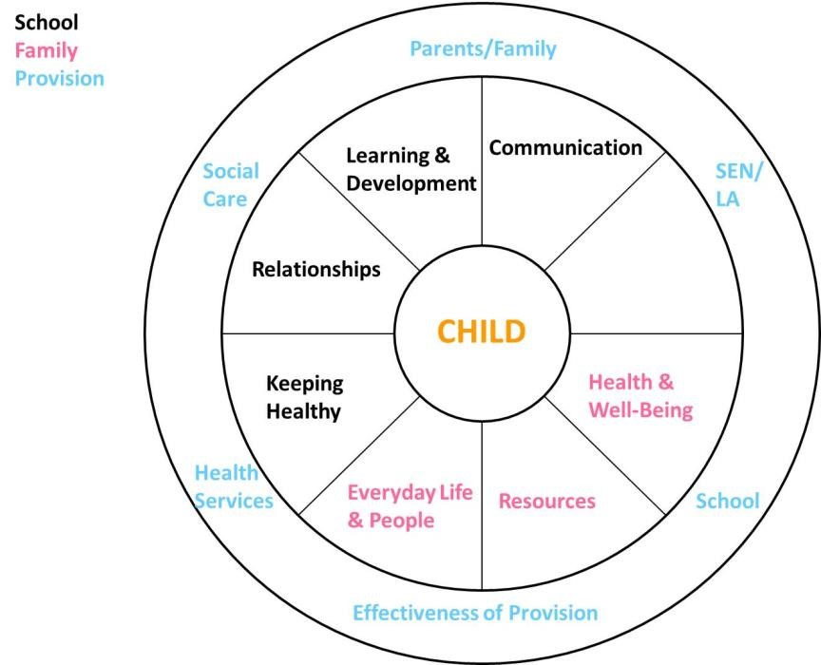

Full name of child / young person: |  | Date of birth: |  | Gender:  Male/Female
Home address: | Setting: |  | Year group:
NHS number: | Language of home: |  | Religion:
Mother’s name: |  | Father’s name:
Address (if different): |  | Address (if different):
Home telephone number: |  | Home telephone number:
Mobile telephone number: |  | Mobile telephone number:
E-mail Address: |  | E-mail Address:

CONSENT STATEMENT FOR INFORMATION STORAGE AND INFORMATION SHARING

Person with parental responsibility / young person if over 16 years old

Name |  | Relationship to child/young person
Best time for contact |  | Best method of contact

Details of any special requirements for child/young person and/or their parent/carer
(e.g. parent’s additional needs, English as a second language, signing, interpretation, access needs, address non-disclosure)

In order for us to identify the needs of your child / young person, and offer services to meet those needs it may be necessary for us to consult with other agencies. We want to ask your permission to share personal information about you and your child / young person with these agencies where it is appropriate to do so.

The purpose of sharing information is to ensure suitable services are provided, through a better understanding of the individual’s strengths and needs. Access to the information will only be given to staff that have a reason to see it.

This information will be recorded and held on file as paper and/or electronic copies and shared with relevant professionals as appropriate. Information can be shared without permission where there might be a child at risk of harm or has been harmed, or where a serious crime has or may be committed. Your information is protected by the Data Protection Act 1998. The information will, therefore, only be used for the reasons stated. It will be kept safe and secure. You have the right to see the information that is being kept about your child / young person.

This consent form is completed at the time of initial contact (or at any other time that seems appropriate), and then placed in the child / young person’s file. Consent is needed for young people under the age of 16 from one parent who has parental responsibility. From the age of 16 young people should sign on their own behalf (where they are deemed competent in accordance with the Mental Capacity Act 2005), and adults with responsibility countersign up until the age of 18.

I give my consent for this information to be shared with any appropriate agency in order to help receive a better service. I understand that by signing this form, it does not affect my rights under the Data Protection or Human Rights law. I understand that at any time I can change or withdraw my consent by notifying the person who has receiving this information.

Signed
 | Name |  | Date
 | Name |  | Date
Countersignature (if required)
Signed

Ethnicity data

White British |  | Caribbean |  | Indian |  | White & Black Caribbean |  | Chinese
White Irish |  | African |  | Pakistani |  | White & Black African
Traveller of Irish Heritage |  | Any other Black background |  | Bangladeshi |  | White & Asian |  | Any other ethnic group
Gypsy/Roma |  |  |  | Any other Asian background |  | Any other Mixed background
Any other White background |  |  |  |  |  |  |  | Not given

People involved in this Child / Young Person’s Life:

It is essential that you provide the latest reports for evidence to support this request.

These can include: Foundry College, Specialist Advisors/Teachers i.e. Early Years/Learning Support/Sensory
Consortium, Health Visitor, Paediatrician/GP, Speech and Language Therapist, Occupational Therapist, Physiotherapist, Neurologist, Audiologist, Ophthalmologist, Social Worker, Primary Parenting Support

Name | Relationship to pupil | Date of report | Report attached | Discharged from service
Family information
 | Child / Young Person
 | Mother
 | Father
Education contacts
 | Class teacher
 | SENCO, Gorse Ride School
 | Educational Psychologist
 | Sensory Consortium Teacher
Health contacts
 | Paediatrician, RBH
 | Physiotherapist
 | SALT
 | OT
 | Cardiac Consultant, GOSH
Social care contacts
 | Family Intervention worker
 | Social worker
 | DCT OT
Other contacts
 | Adviza
 | Youth worker
 | YOT worker

One page profile

Child / Young person’s view:
E.g. What I like about school, who I like to help me, what I would like to be when I  grow up | How best to support me  My aspirations and hopes for adult life
Parent(s) / Carer(s)’s view:
E.g. What type of support does your child benefit from, What do you hope your  child will  achieve when they are an adult | How best to support my child  My aspirations and hopes for my child in adult life
Background (include all relevant information from birth to now, including any diagnoses and please attach relevant reports):

Educational needs

This section focusses on strengths and any needs that impact on their education

Cognition and learning

e.g.  progress at school, memory, attention and concentration, homework, favourite lessons, attendance, exclusions | Strengths / what is working:
 | What I find difficult:

Communication and interaction

e.g.  understanding, how they communicate, social and  interaction  skills | Strengths / what is working:
 | What I find difficult:

Emotional wellbeing

e.g.  general mood, understanding of emotions, confidence, relationships, risk taking, anxiety, behaviours | Strengths / what is working:
 | What I find difficult:

Sensory and / or physical

e.g. | Strengths / what is working:
vision, hearing,
physical skills handwriting, co-ordination,
sensory
difficulties
 | What I find difficult:

Health needs

This section focusses on strengths and any health needs

e.g.  lifestyle, sleeping, diet, allergies, toileting, smoking | Strengths / what is working:
 | What I find difficult:

Is there a Health Needs Plan in place?
Is there a Risk Assessment for their Health needs in place?

My family

This section concerns family life that is likely to have an impact on the child / young person’s learning progress.

The family unit
e.g. close and
extended
family, single parent family / multiple family homes

e.g. | Strengths / what is working:
cooperation, sharing bedrooms, going out as a family, holidays, joining in the community
 | What I find difficult at home:

Supporting my child and family is or I am receiving (if over 16 years old)
e.g. short breaks, direct payments, PIP, housing benefits

Is the child or young person a Child in Care or Looked After by the Local Authority?
Is the child or young person subject to Child Protection or an Order e.g. Special Guardianship?
Is the child or young person a Child In Need or is there a Team around the Child?
Does the child receive Free School Meals / Pupil Premium?
Would you identify your family as a Traveller family?
Are you an Armed Forces family?

It is essential that you provide the latest copies of plans/reports for evidence to support this request.

Please email this form to:
SENDEHCAssessments@wokingham.gov.uk

