NOTICE
Notice
of
an
application
to
modify
or
discharge
a
planning
obligation
under
section
106
a
of
the
Town
and
Country
Planning
Act
1990
I
give
notice
that
(
insert
name
of
applicant):
Is
applying
to
Wokingham
Borough
Council
to
modify
the
planning
obligation
described
below.
Planning
obligation
Obligation:
(
brief
description
of
the
planning
obligation
which
the
applicant
wishes
to
have
modified
or
discharged)
Land
to
which
obligation
relates:
(
address
or
location
of
the
land)
Date
on
which
obligation
was
entered
into:
(
relevant
date)
Any
person
against
whom
the
planning
obligation
is
enforceable
who
wishes
to
make
representations
about
this
application
should
write
to
the department at Development Management, Civic Offices,
Wokingham, Berks, RG41 1BN
by
(
enter
date
giving
a
period
of
21
days
beginning
with
the
date
of
service
or
publication
of
the
notice
as
the
case
may
be)
..........................................
Members
of
the
public
will
be
invited
to
make
representations
when
the
application
has
been
submitted
to
the
council.
Signed................................................................................................Date..................................................
(
if
appropriate)
on
behalf
of
............................................................................................................................
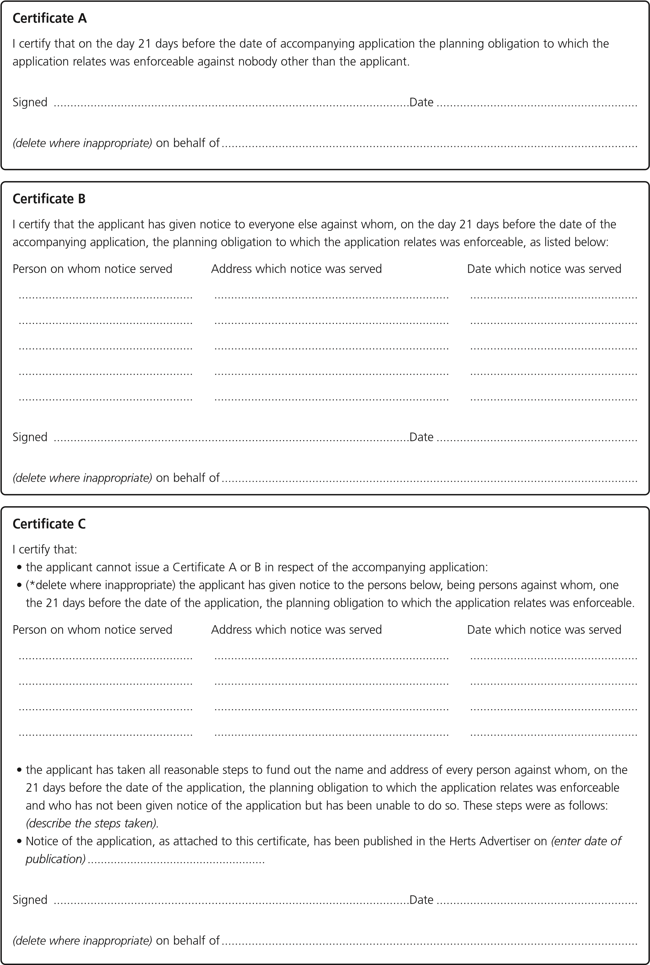
(
relevant local paper

